TRAINING REPORT ON PROFITABLE STEPS TO CONTEMPORARY EXPORT AND IMPORT

1
BACKGROUND

- International Trade represent a significant share of Gross Domestic Product (GDP) in many countries. Thus, it impacts directly on Industrialization, Technology, and Transportation, Banking, Politics and Culture of a Country.

- This training will create awareness on contemporary issues on dynamics of International trade as they unfold to improve earnings of organization through avoidance of bottlenecks in all areas.
PARTICIPANTS PROFILE
S/n | Empl ID | Names | Grade | Staff Location
1 | A14999 | Funmilola Orogbangba | ASO | Head Office, Lagos
2 | A19158 | Dapo Olofintuyi | ABO | Head Office, Lagos
3 | A19303 | Motunrayo Odudu | ET | Head Office, Lagos
4 | A19284 | Kenneth Obasuyi | ET | Head Office, Lagos

OTHER PROGRAMME DETAILS
Date: 16th – 18th March, 2016

Venue: Centre for Management Development (CMD), Old Toll
gate, Lagos

Time: 8.00am – 4.00pm daily

2
FACILITATOR’S ASSESSMENT

Facilitators Evaluation:

Interswitch Faculty members who facilitated the course were appraised at the end of their session on the criteria below:

- Exhibited good Knowledge of the Subject Matter
- Demonstrated professional credibility regarding subject matter
- Delivered an organized and well prepared presentation
- Encouraged participation and appeared approachable
- Checked participants' level of comprehension
- Covered the subject thoroughly
- Effectively delivered their modules

Please see below the diagrammatical representation of the facilitators’ assessment

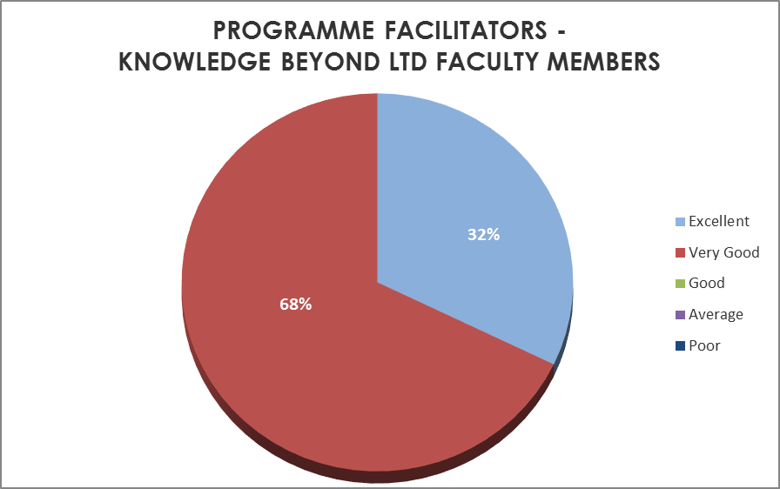

TRAINING EVALUATION
3

The charts below represent the assessment carried out on the participants with respect to the course undertaken and programme in general.

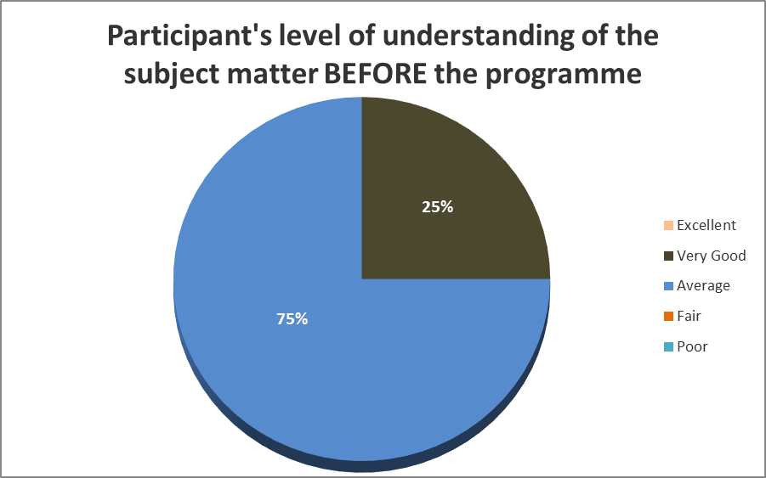

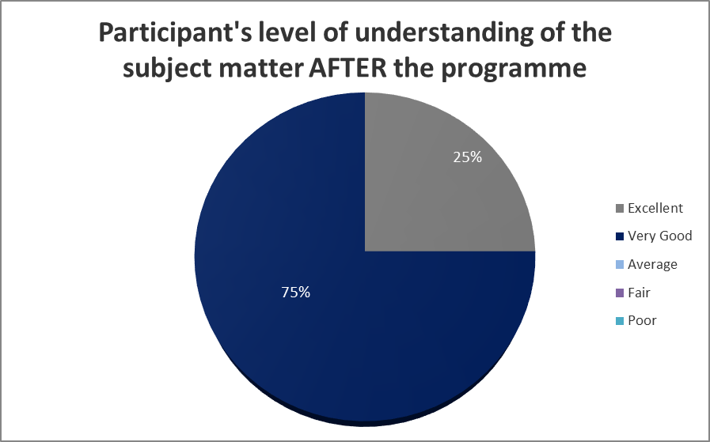
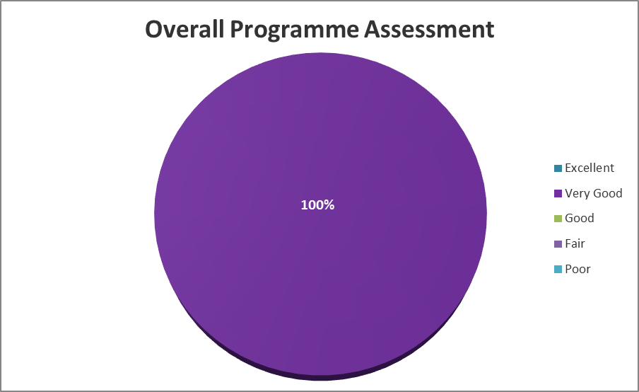

BUDGETED COST VS ACTUAL

4

Please see below cost expended on the programme:

ITEMS | BUDGETED AMOUNT (N) | ACTUAL SPENT (N) | SAVINGS  (N)
Course Fee | 340,000.00 | 340,000.00 | 0.00
Total | 340,000.00 | 340,000.00 | 0.00

5
PARTICIPANTS’ COMMENTS

Below are some of the comments made by the participants of the programme:

- “The training programme covered basic areas on trade. We suggest more intensive/elaborate trainings.”

- “It was impactful, insightful, interactive and an eye opener on Export transaction.”

- “More of such programs should be arranged especially for Trade Services.”

- “The training environment was one of the best aspect of the programme.”

5
CONCLUSION

The table below shows a summary of the Facilitators/Training evaluation:

s/n | Facilitator’s Evaluation | % of Participants | Ranking
1 | Facilitator’s rating based on criteria above | 32 | Excellent
1 | Facilitator’s rating based on criteria above | 68 | Very Good
 | Training Evaluation
2 | Participants level of understanding of the subject matter BEFORE the programme | 25 | Very Good
2 |  | 75 | Average
3 | Participants level of understanding of the subject matter AFTER the programme | 25 | Excellent
3 |  | 75 | Very Good
4 | Overall programme Assessment | 100 | Very Good

From the table above, we can deduce that the participants were quite pleased with the exposure they got on the subject.

They suggested that more Trade related programs be organized in favour of the larger Trade Services Group and also commended the training environment.

Thank you.

Orusoso Isioma-Nwaligbe Abayomi Orungbe
TM, UBA Academy Group 1 Head, UBA Academy Group 1

